**First-in-first-out Data Structure**

[Report Issue](https://github.com/LeetCode-Feedback/LeetCode-Feedback/issues)

In a FIFO data structure, the first element added to the queue will be processed first.

As shown in the picture above, the queue is a typical FIFO data stucture. The insert operation is also called enqueue and the new element is always added at the end of the queue. The delete operation is called dequeue. You are only allowed to remove the first element.

*Example - Queue*

1. Enqueue: you can click Enqueue below to see how a new element 6 is added to the queue.

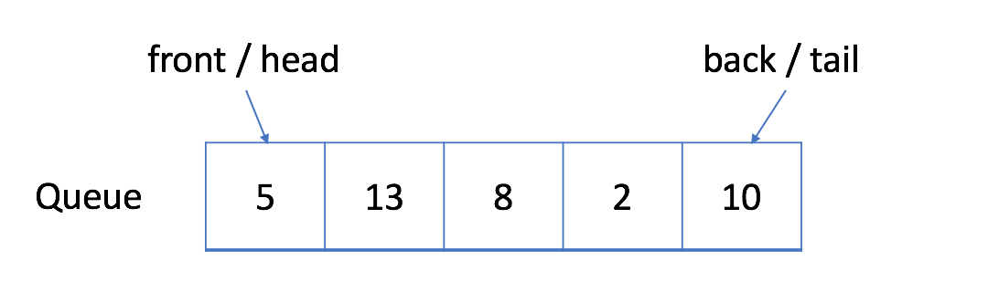    Enqueue

    Reset

2. Dequeue: you can click Dequeue below to see which element will be removed.

    Dequeue

    Reset